UNIVERSITY OF WAH (UOW)
DEPARTMENT OF COMPUTER SCIENCE



BSCS 3RD B

REG #: UW-24-CS-BS-088

SUBMITTED BY: SAADI SAFDAR

SUBMITTED TO: SIR. HASSAN SHAFAQAT

COURSE TITLE: COMPUTER NETWORKS

COURSE CODE: CS – 241 L

LAB REPORT # 7

Initial Network Topology The unconfigured network topology is presented, comprising two 1841 routers, two 2950-24 switches, and eight PCs (PC0 through PC7).
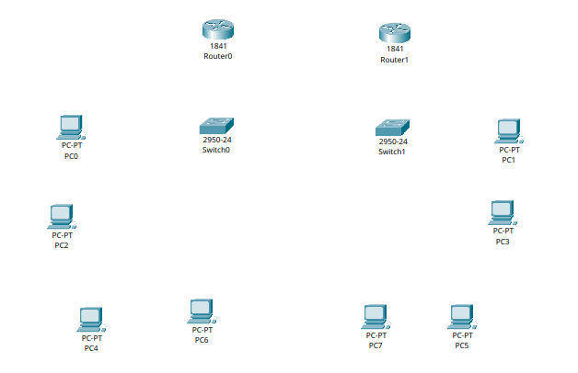

Physical Layer Implementation and Connections Physical connections were established: Router0 is connected to Switch0, Router1 to Switch1, and a cross-connection links Router0 and Router1. The host devices (PC0, PC2, PC4, PC6) are connected to Switch0, and the remaining hosts (PC1, PC3, PC5, PC7) are connected to Switch1.

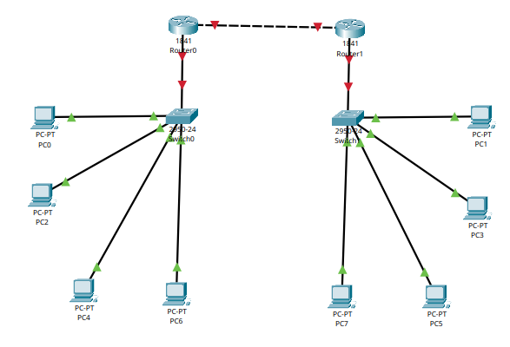

Interface Configuration for Inter-Router Link (FastEthernet0/0) The IP address configuration for the inter-router link is detailed. Router0's FastEthernet0/0 interface was configured with 192.168.88.1, and Router1's FastEthernet0/0 was configured with 192.168.88.2 (Subnet Mask: 255.255.255.0). The equivalent Cisco IOS commands used for this configuration are included below.
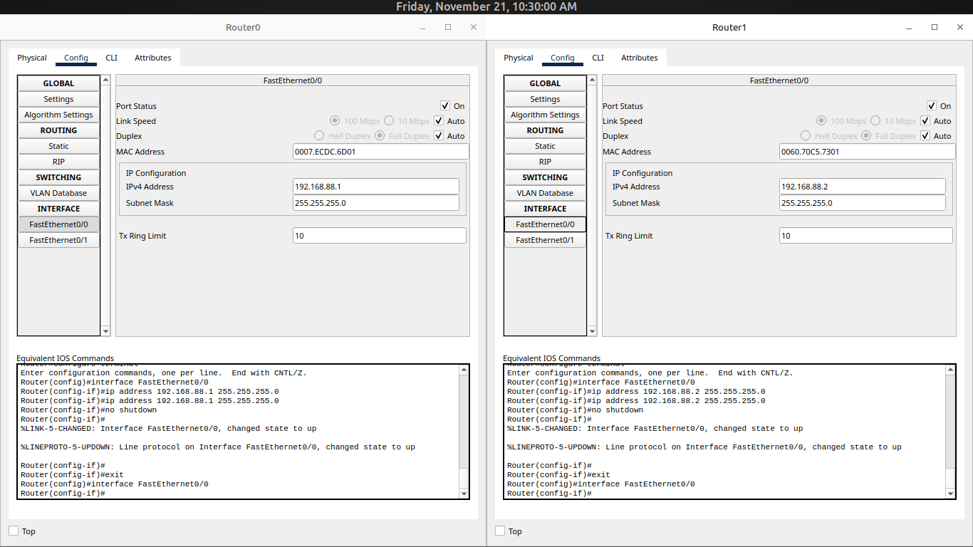

Gateway Interface Configuration for Local Area Networks (FastEthernet0/1) The IP addresses acting as the Default Gateways for the respective LANs are configured. Router0's FastEthernet0/1 was set to 192.168.89.1, and Router1's FastEthernet0/1 was set to 192.168.90.1 (Subnet Mask: 255.255.255.0).
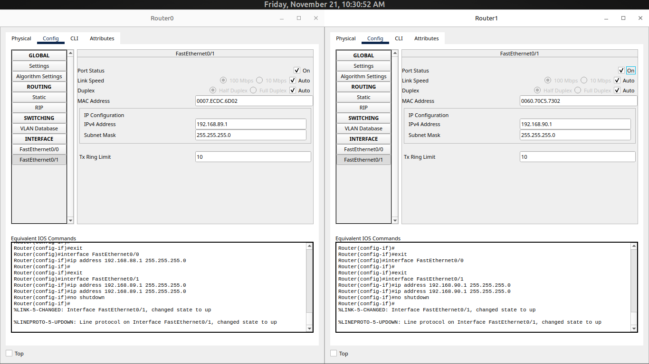

Static IP Addressing for LAN 1 Host Devices (192.168.89.0/24) The static IP configuration for the host devices on LAN 1 (connected to Switch0) is verified. All devices (PC0, PC2, PC4, PC6) were assigned addresses within the 192.168.89.0/24 network, with the Default Gateway correctly set to 192.168.89.1.
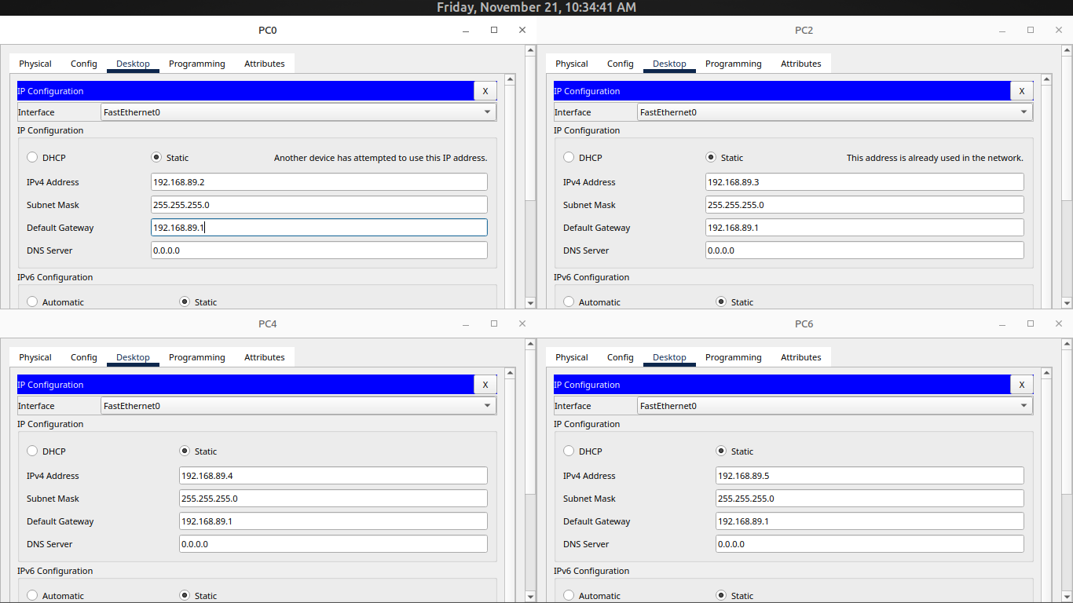

Static IP Addressing for LAN 2 Host Devices (192.168.90.0/24) The static IP configuration for the host devices on LAN 2 (connected to Switch1) is verified. All devices (PC1, PC3, PC5, PC7) were assigned addresses within the 192.168.90.0/24 network, with the Default Gateway correctly set to 192.168.90.1.
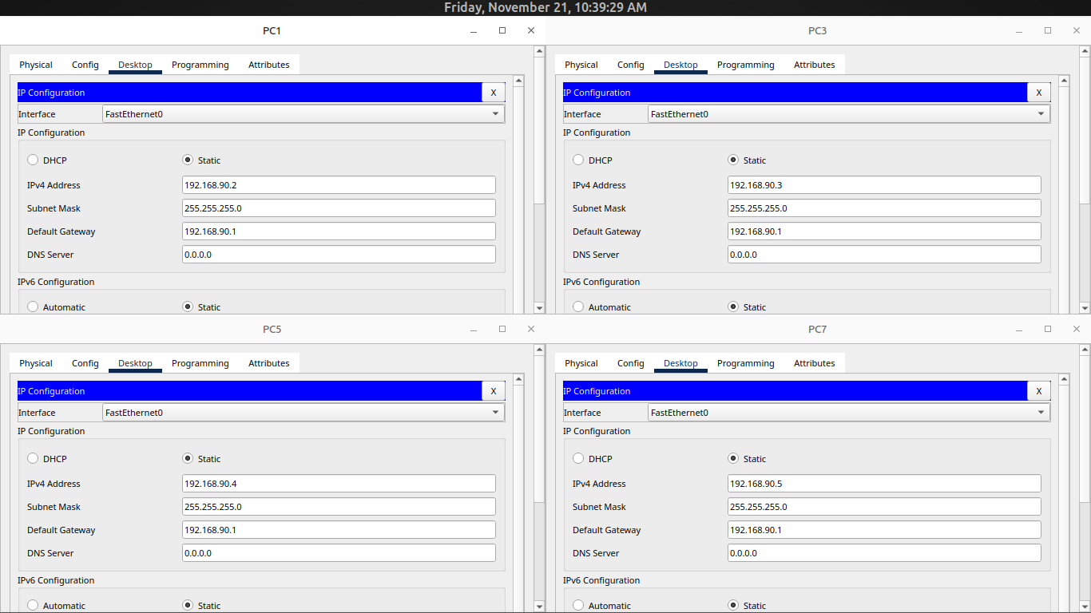

Fully Addressed Network Topology A complete visual representation of the network is provided, detailing the IP addressing scheme across all interfaces and host devices, illustrating the three distinct subnets: 192.168.88.0/24, 192.168.89.0/24, and 192.168.90.0/24.

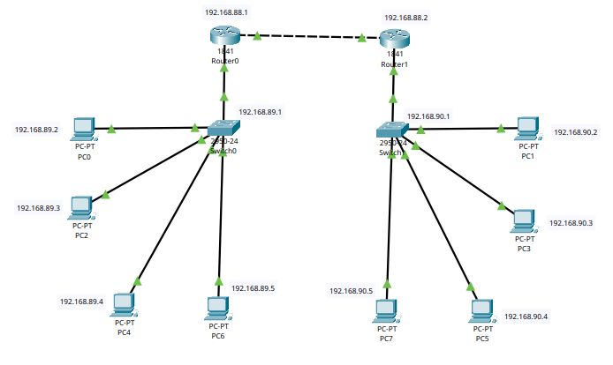

Implementation of Static Routes via CLI The specific Cisco IOS commands utilized to implement static routing on the routers are displayed: * On Router0: A route to the 192.168.90.0/24 network is defined via the next-hop address 192.168.88.2. * On Router1: A route to the 192.168.89.0/24 network is defined via the next-hop address 192.168.88.1.
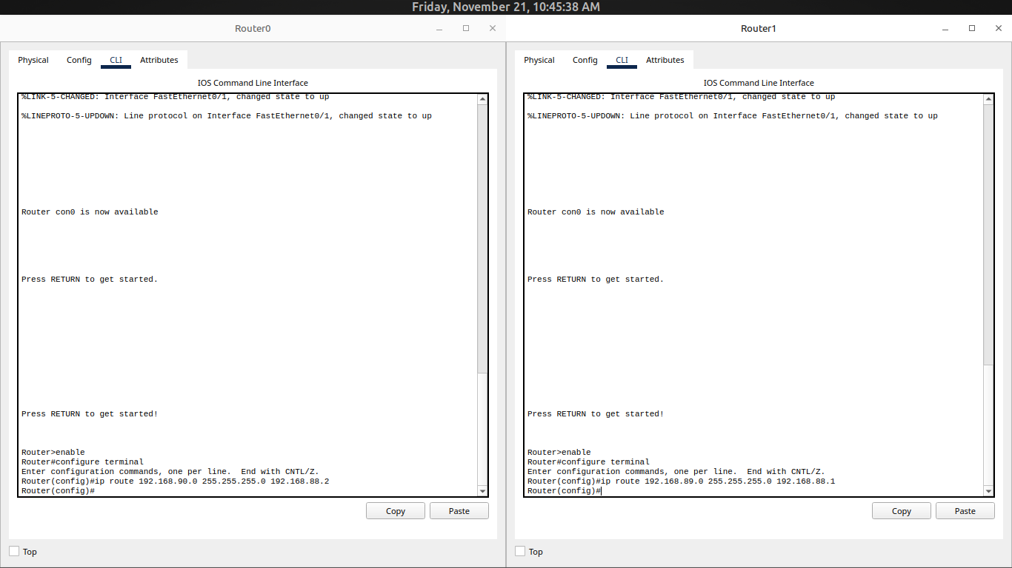

Verification of Static Routing Table Entries The static routes configured in the previous step are verified using the router's GUI/web interface, showing the remote Network Address, Subnet Mask, and the Next Hop address for both Router0 and Router1.
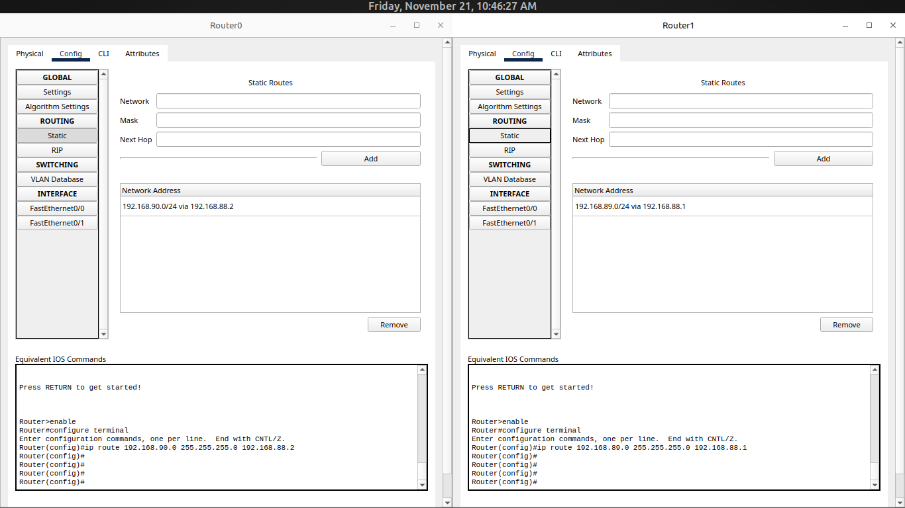

1. Pings from PC0 (Source IP: 192.168.89.2)
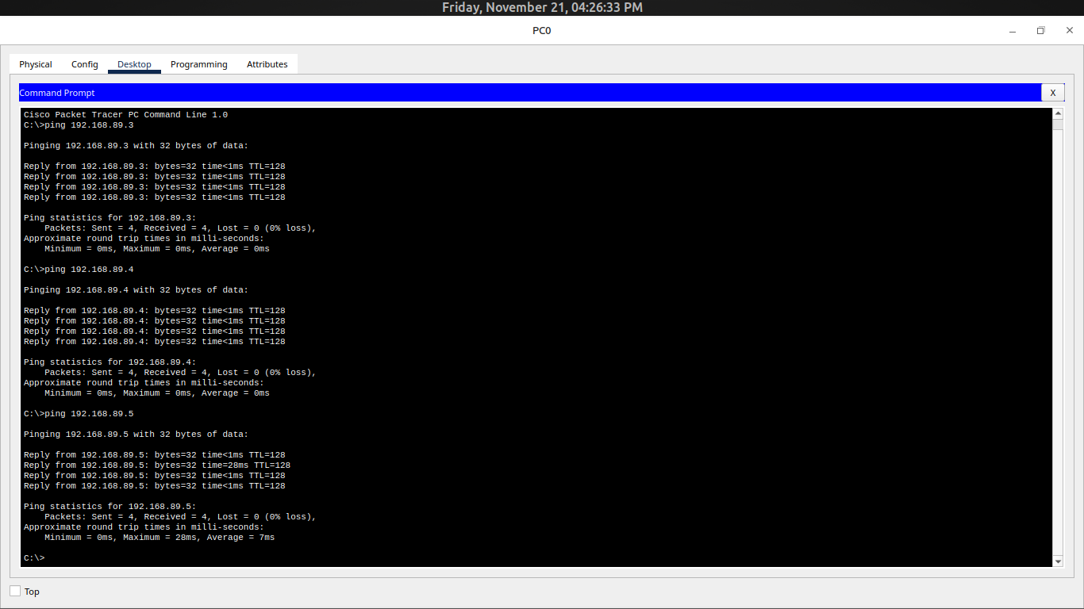
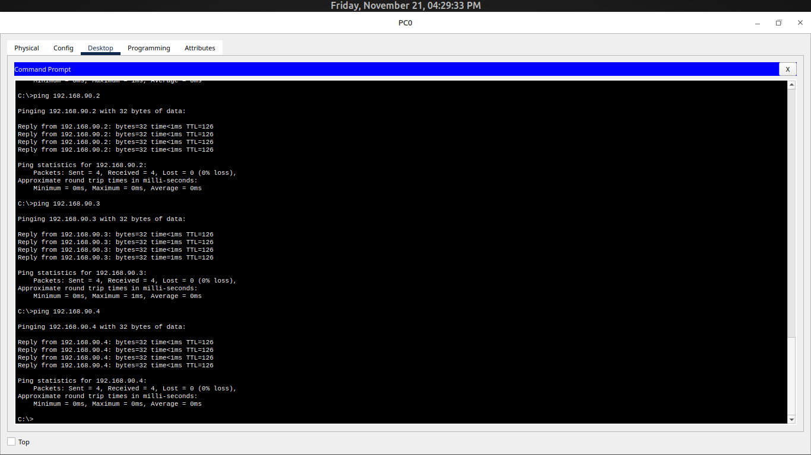

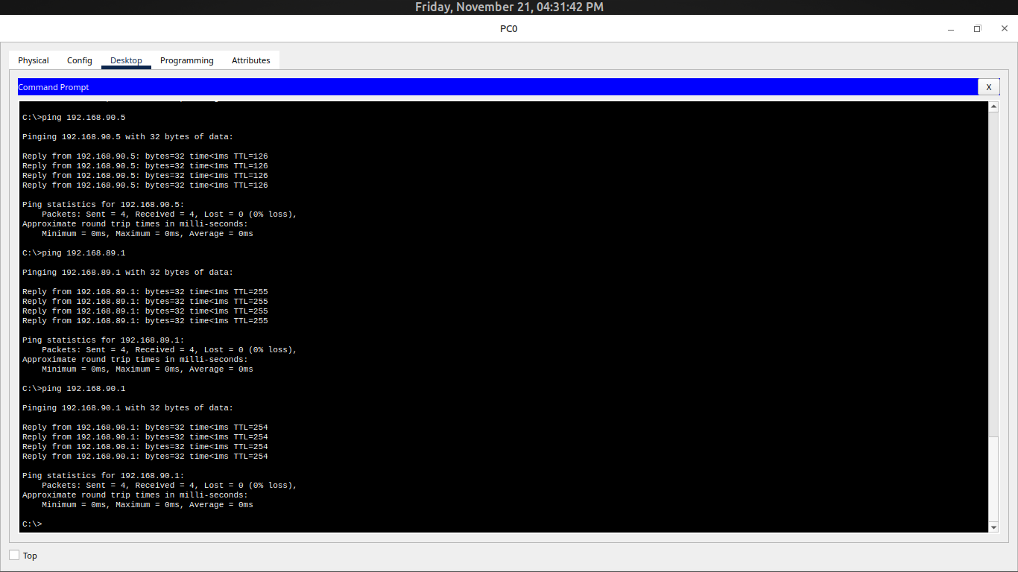

2. Pings from PC1 (Source IP: 192.168.90.2)
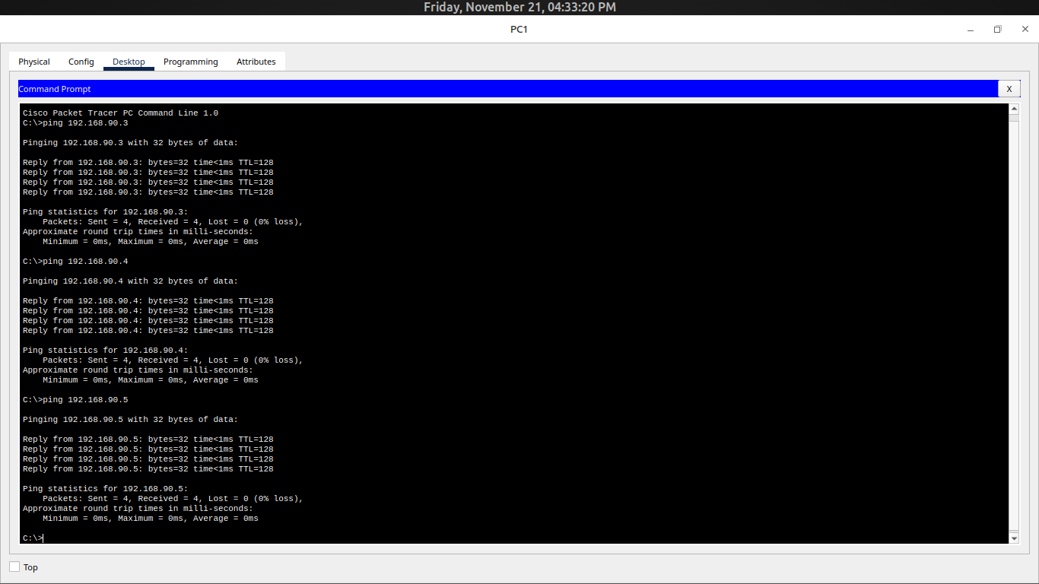

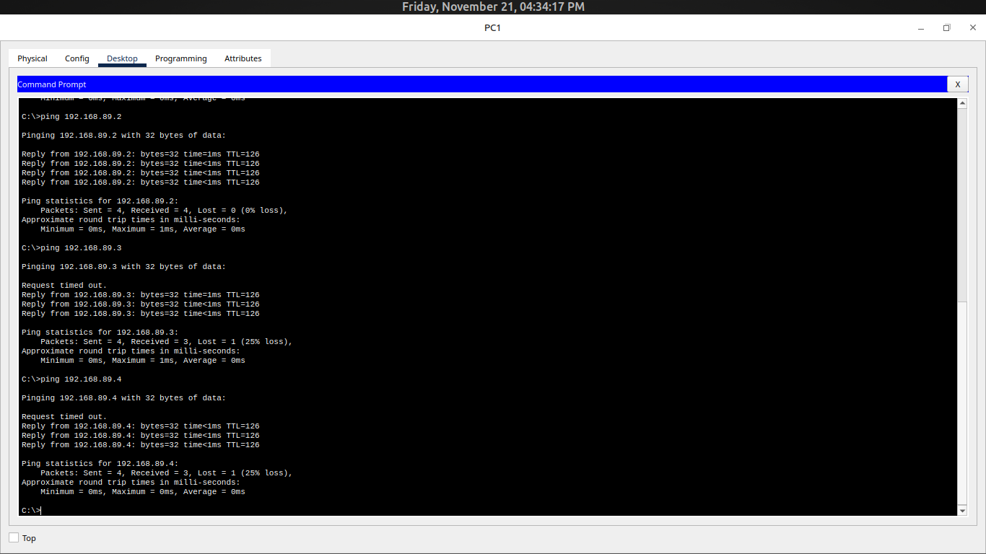
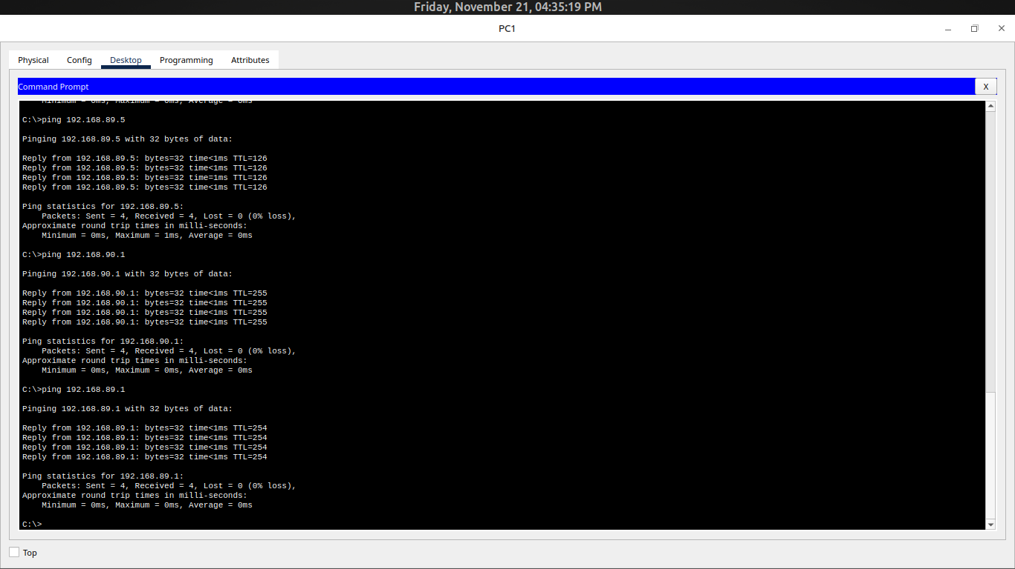

3. Pings from PC2 (Source IP: 192.168.89.3)
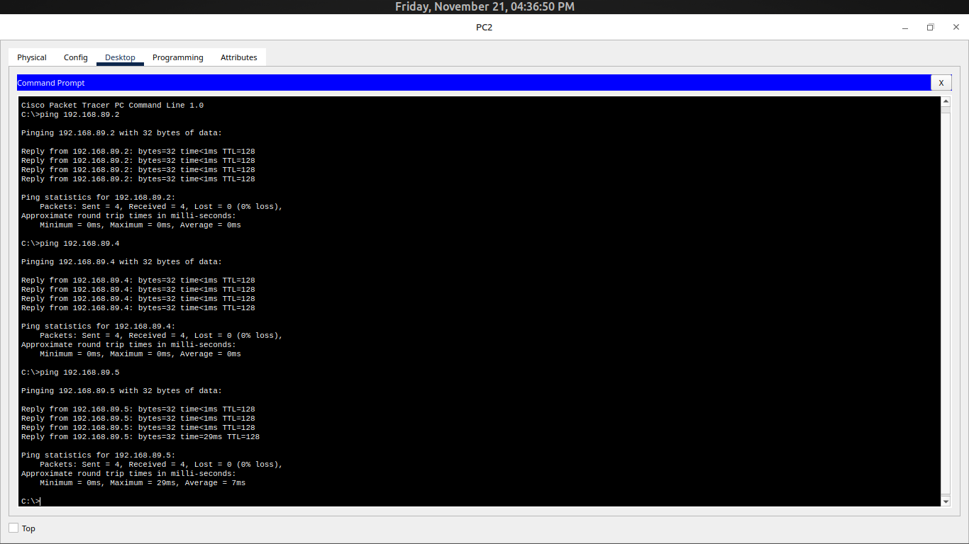
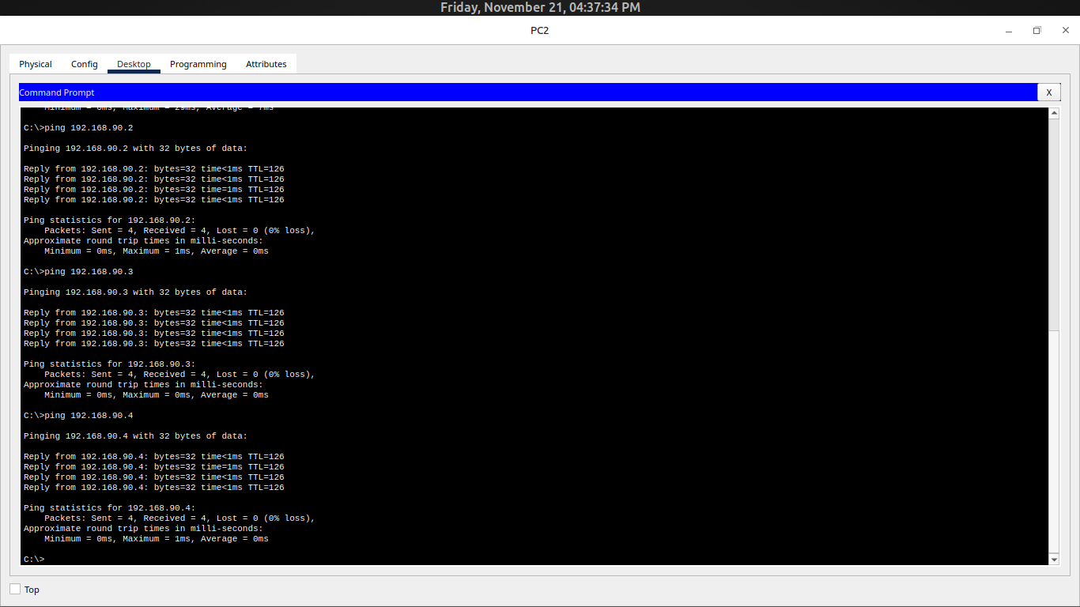

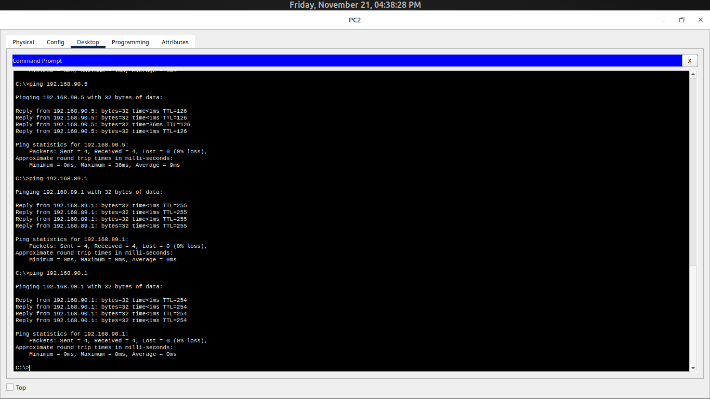

4. Pings from PC3 (Source IP: 192.168.90.3)
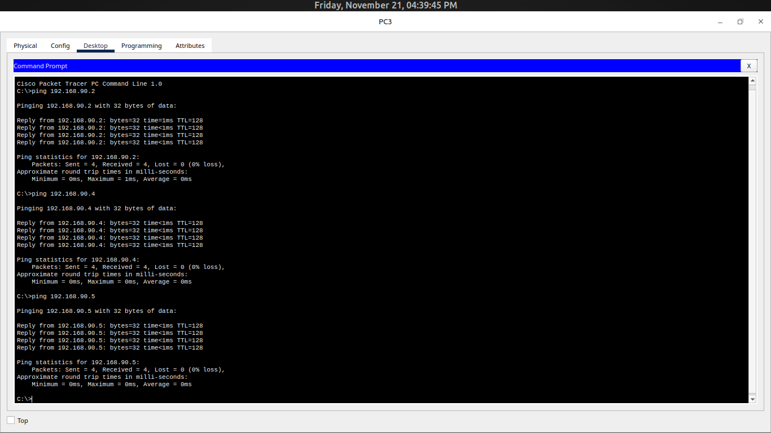

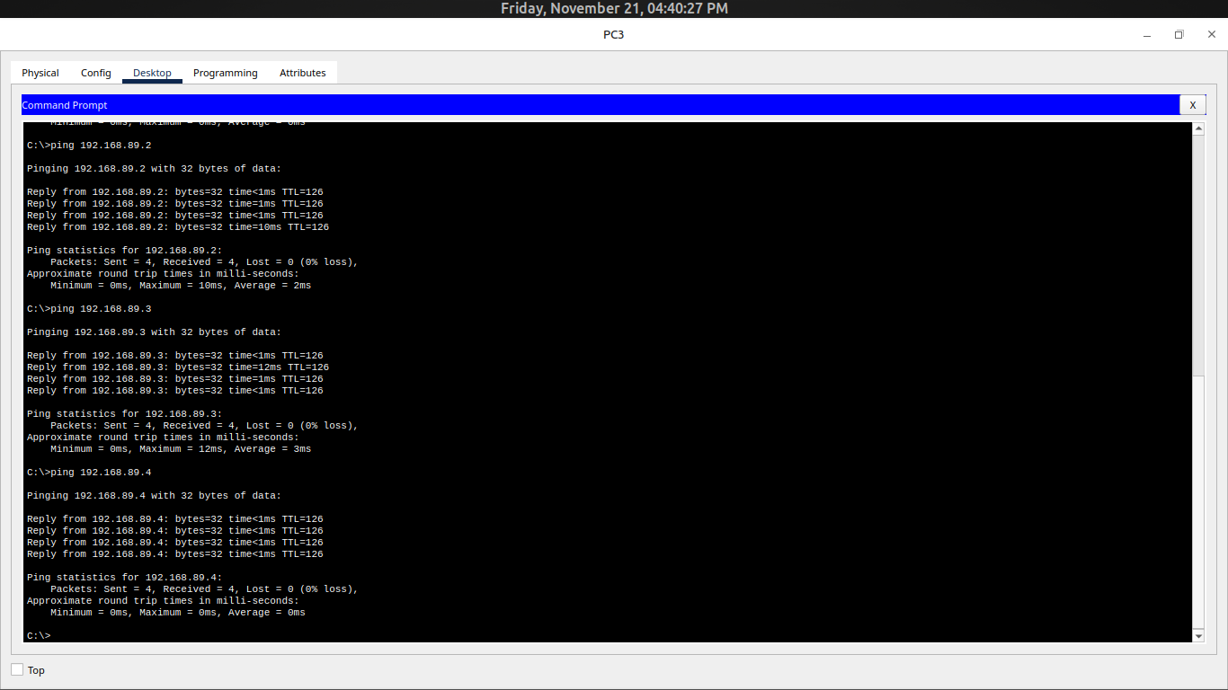
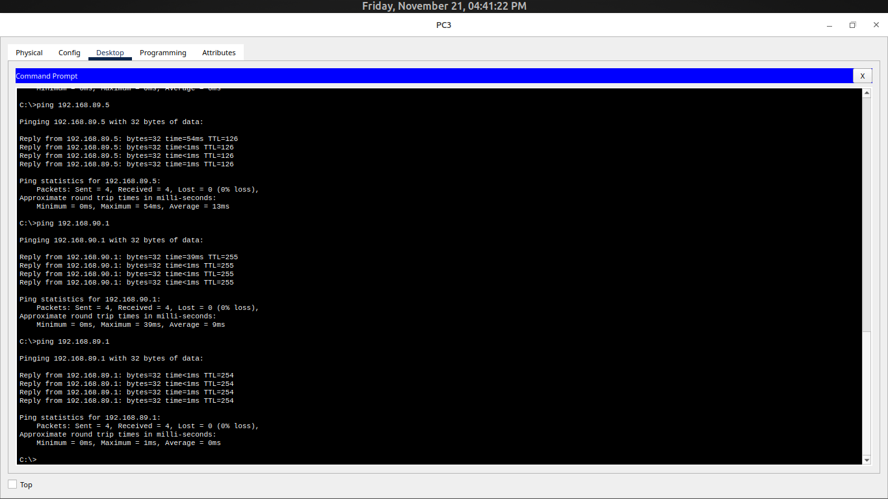

5. Pings from PC4 (Source IP: 192.168.89.4)
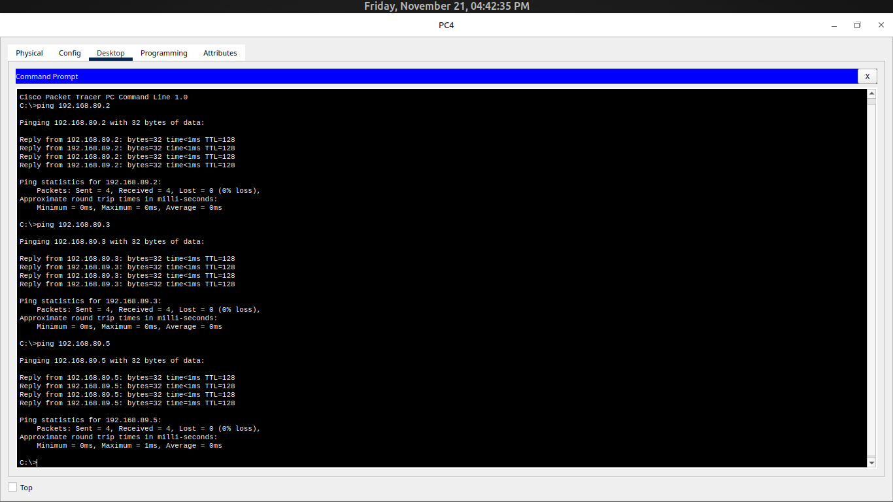
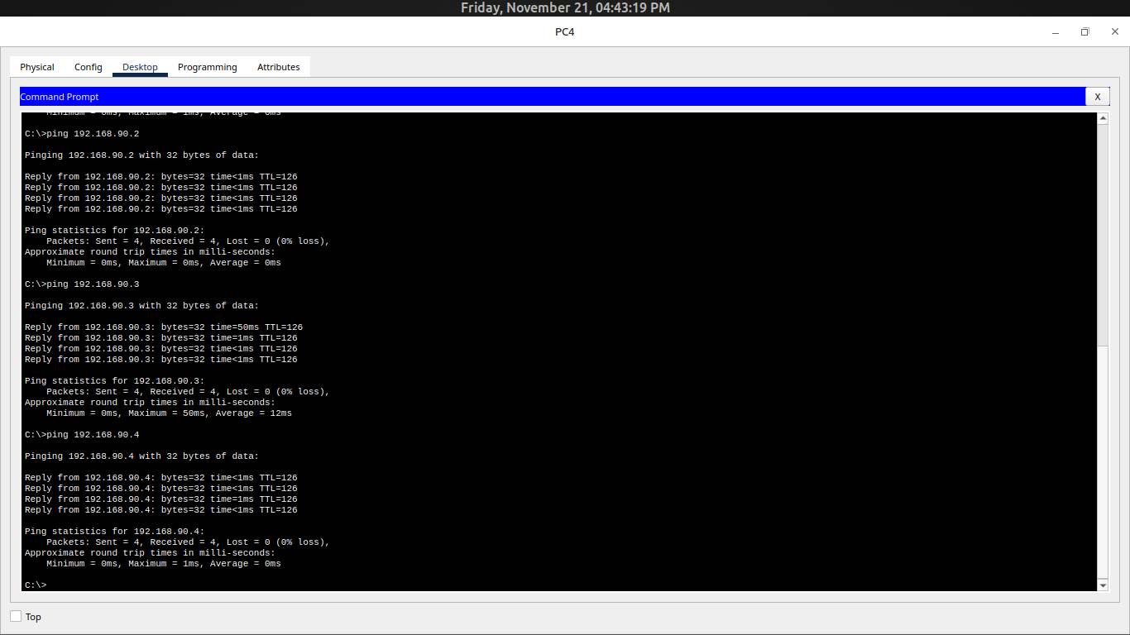

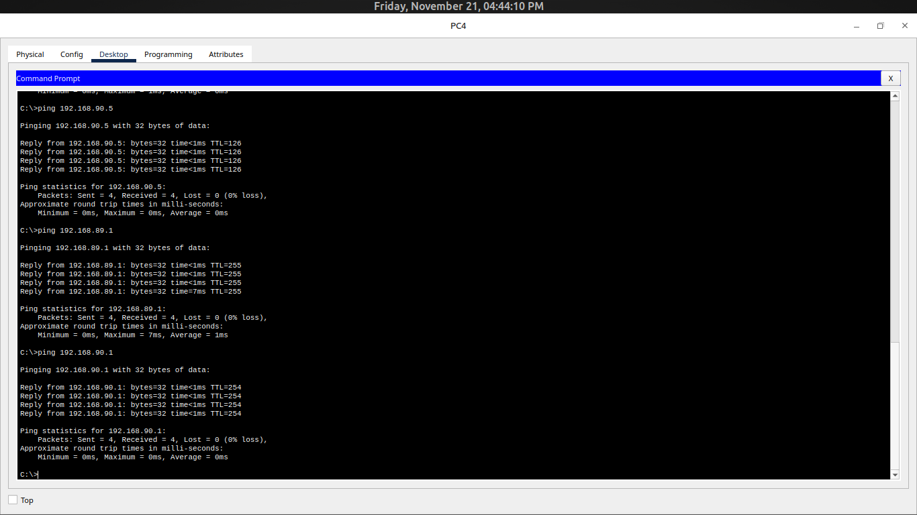

6. Pings from PC5 (Source IP: 192.168.90.4)
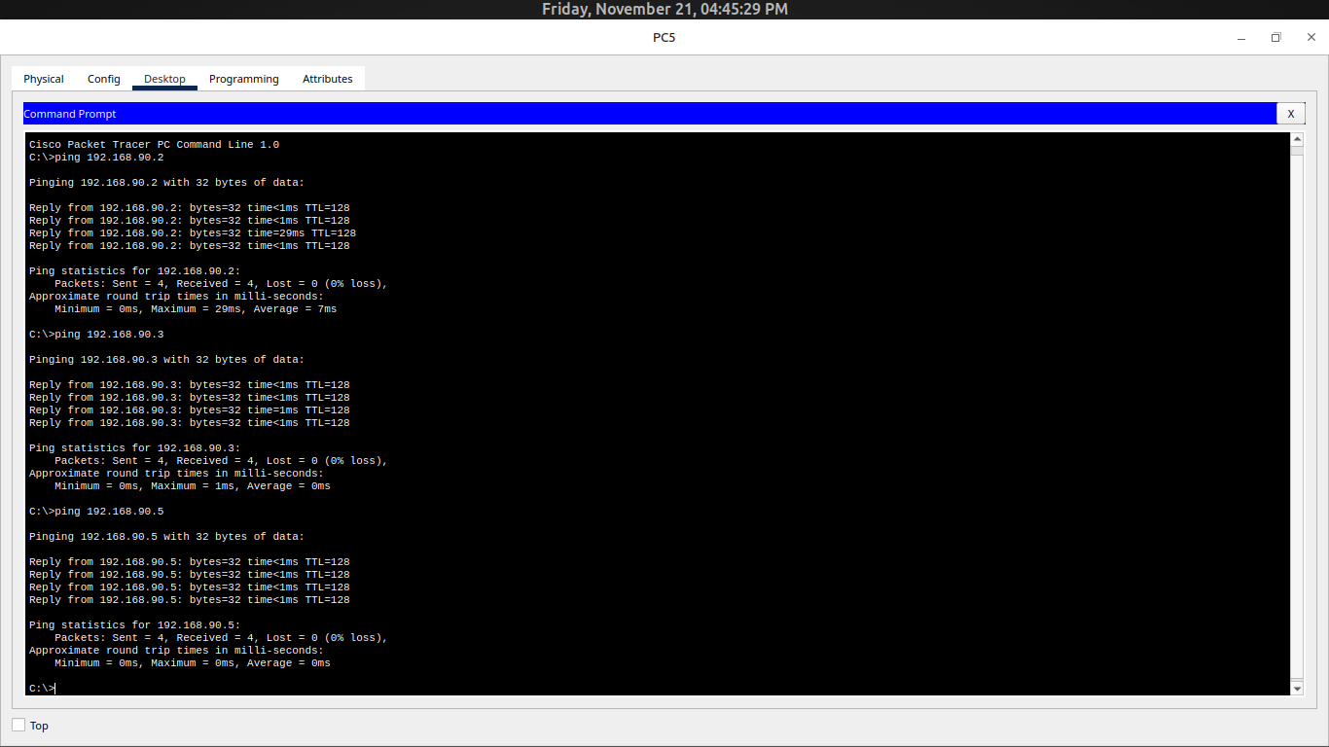

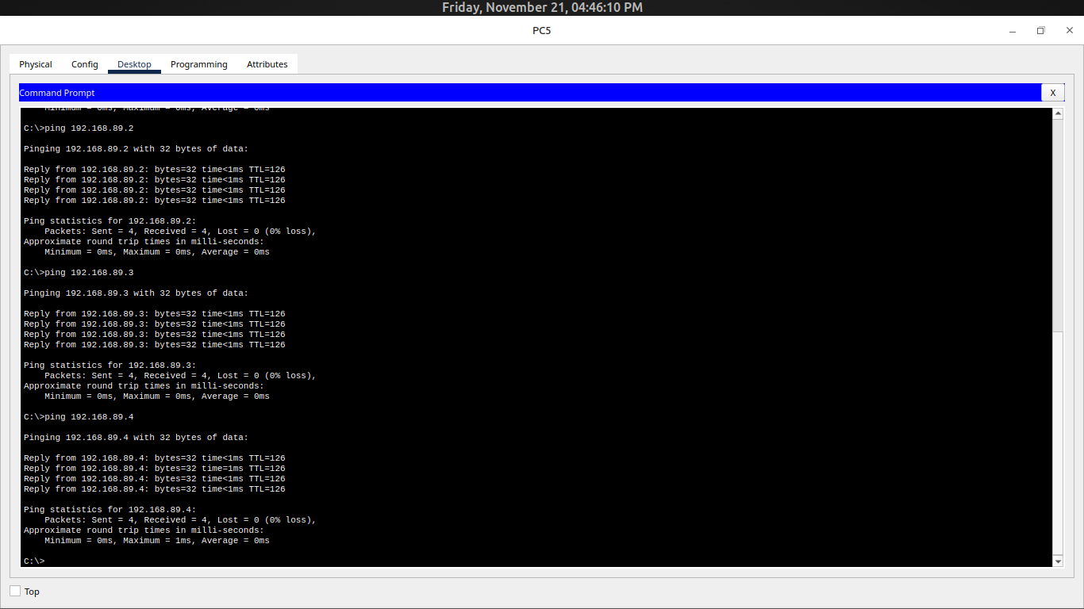
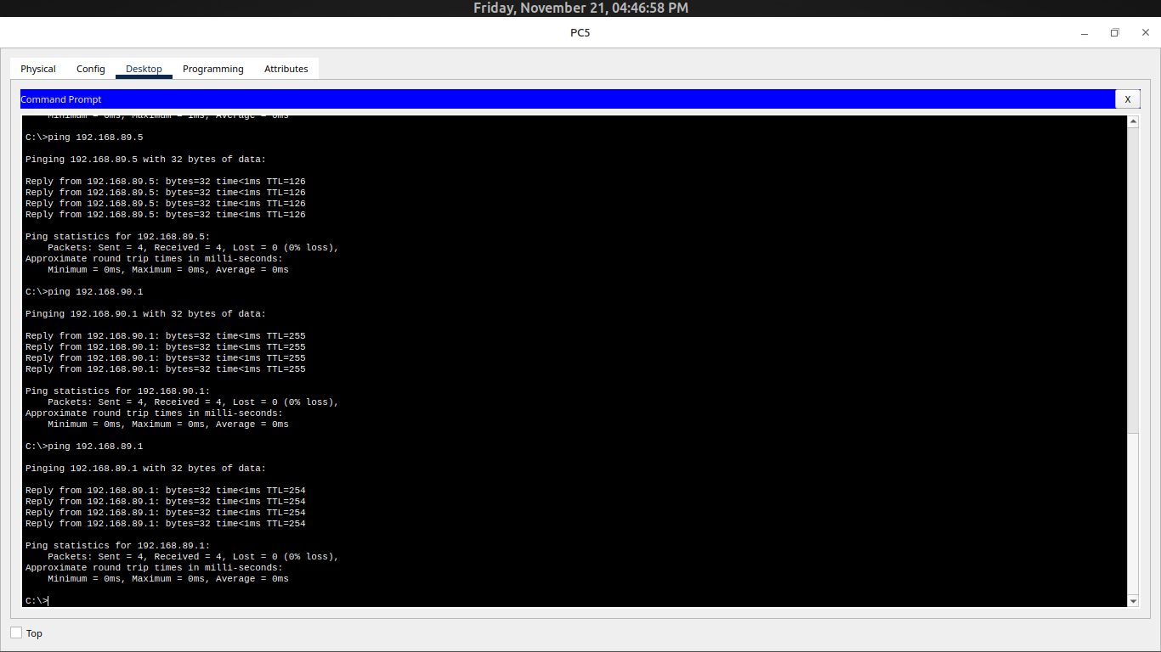

7. Pings from PC6 (Source IP: 192.168.89.5)
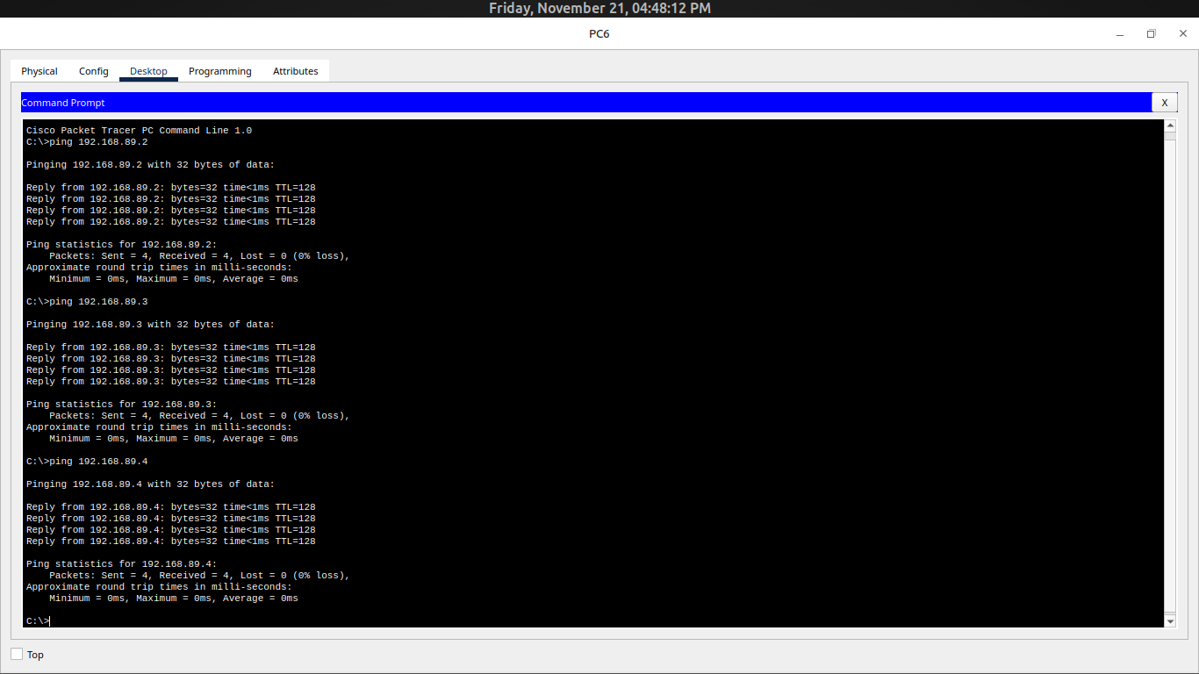
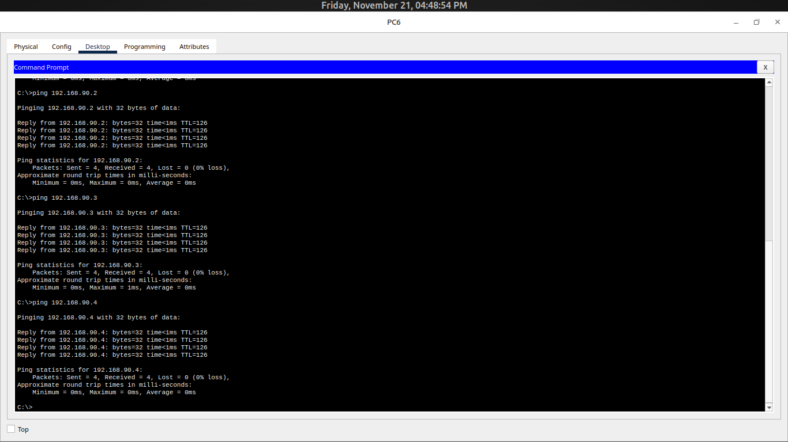

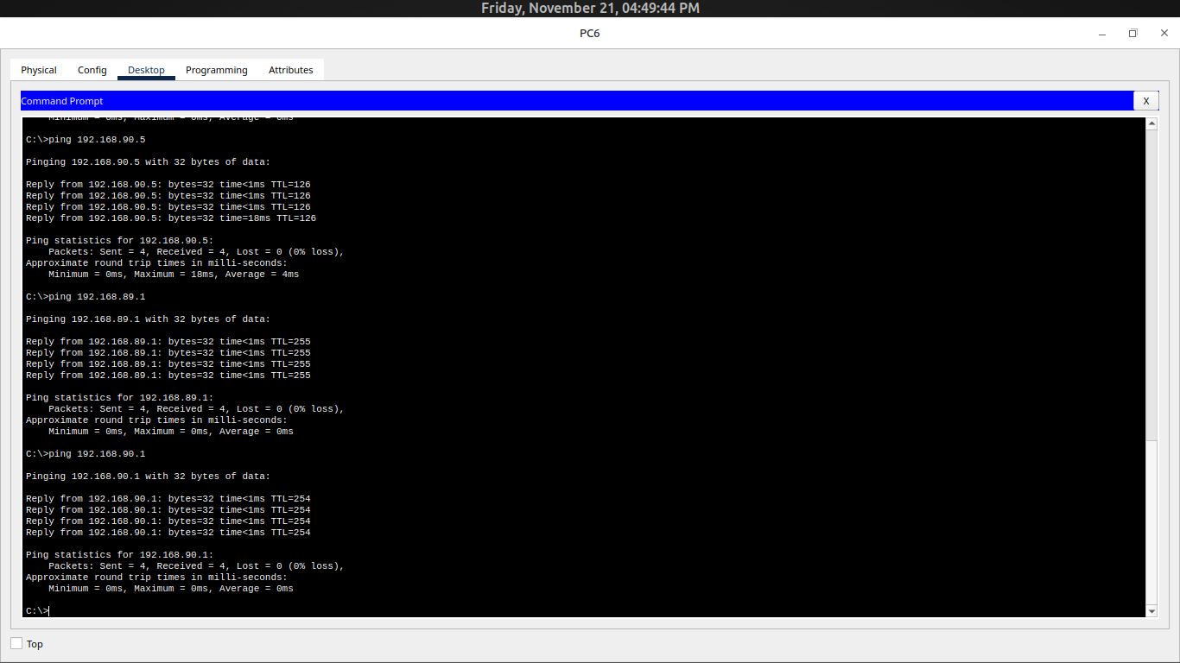

8. Pings from PC7 (Source IP: 192.168.90.5)
